Preparation and Maintanence **of** ZOHO Books for Techpro Solutions

Project Team Members:

SANGEETHA.S

SARMILA.M

SATHYA.A

SRINANDHINI.B

**1. INTRODUCTION**

**1.1 Overview:**

TechPro Solutions, an IT services company, utilizes Zoho Books to efficiently manage their client billingand invoicing. They track project expenses, record billable hours, and generate professional invoicesusing Zoho Books. The software helps them streamline their financial processes and provides insightsinto their profitabilityTechPro Solutions is a Private Limited company also registered under GST in Tamil Nadu. TechProSolutions offers various expert IT consulting services in India and outside India.

**1.2 Purpose:**

By maintenance of accounts in ZOHO Books, We have created the Items, Vendors creation, Preparation of Purchase Order, Purchase Invoice, Customer creation, Preparation of Sales order, Sales Invoice, creation of bank account, creation of new accounts, recording journal entries, recording expenses, recording bank receipts and payments and viewing of financial reports like Profit & Loss account, Balance sheet, GST Reports, Journal report, Account receivable summary report, Account payable summary report, etc.,

**2. Problem Definition & Design Thinking**

2.1EMPATHY MAP

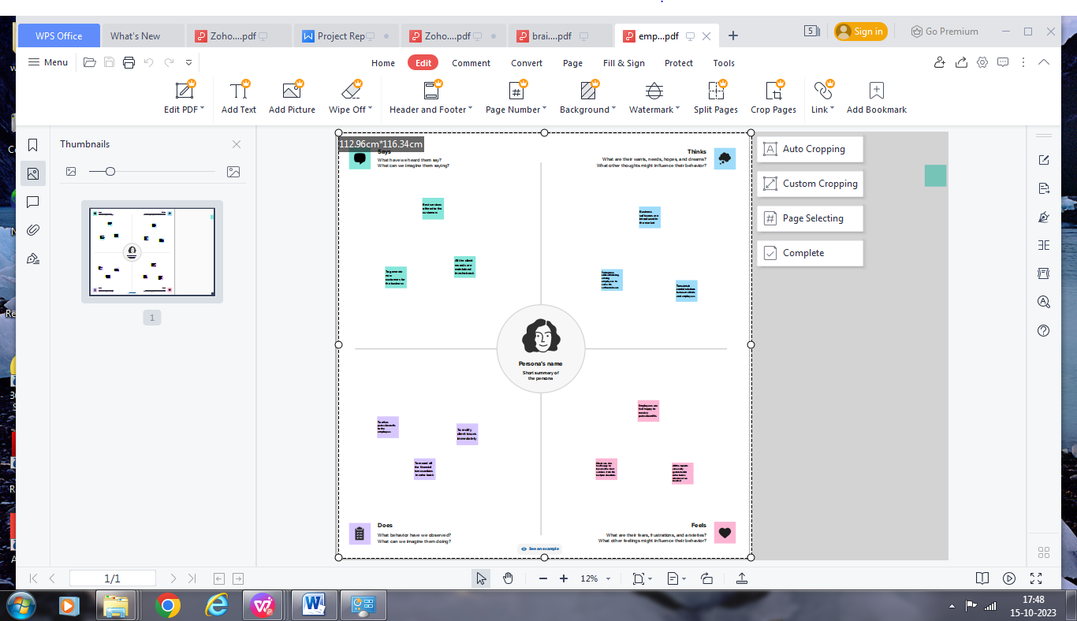

2.2 Ideation & Brainstorming Map

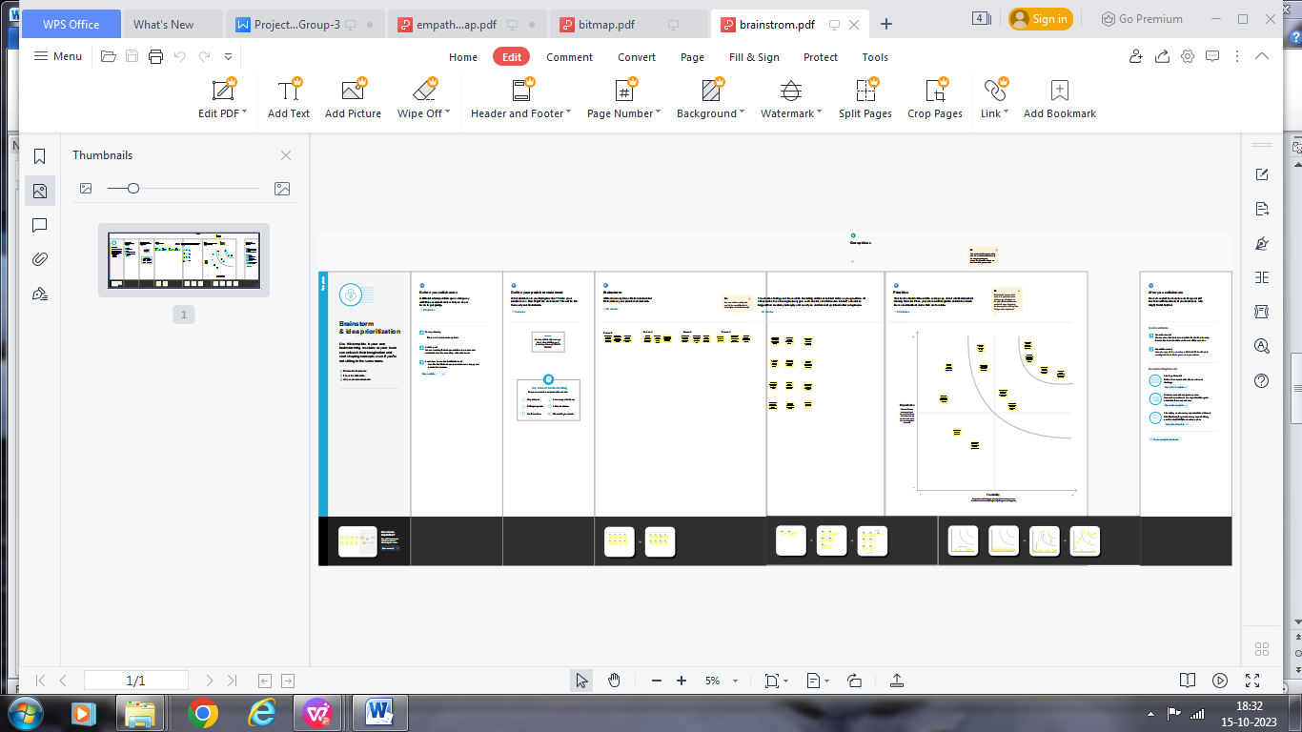

**3. RESULT:**

To Generate the Financial Reports:

Profit and Loss Account:

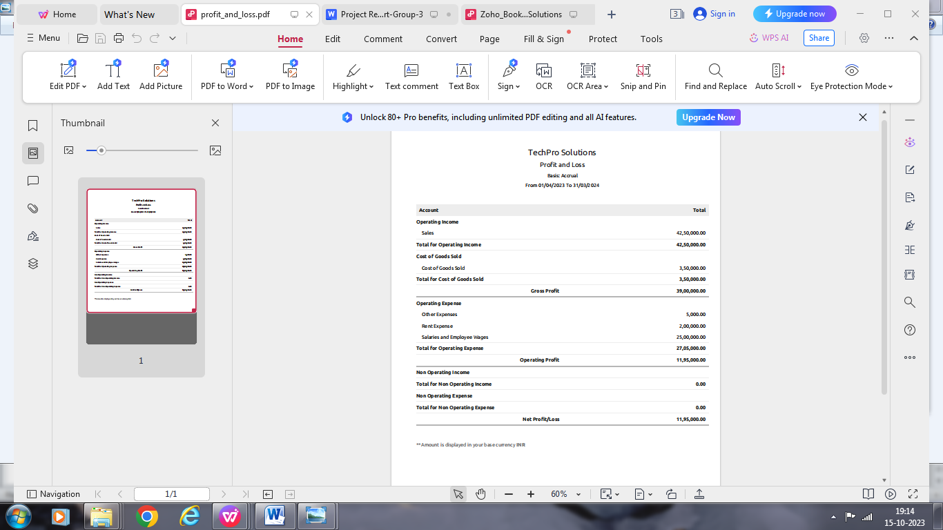

2. Balance Sheet

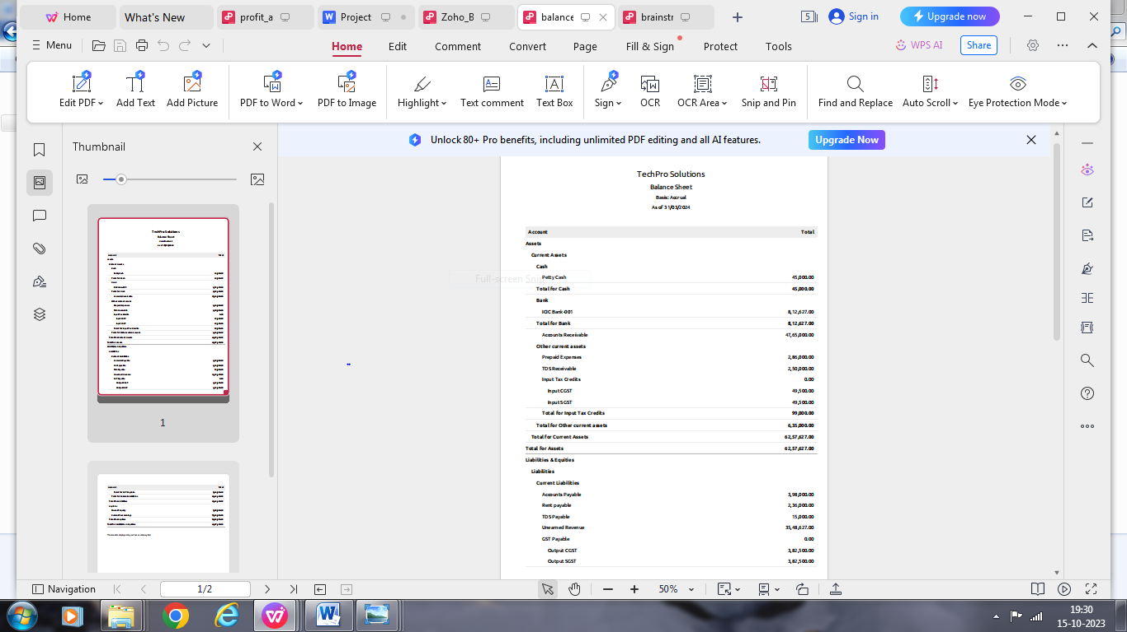

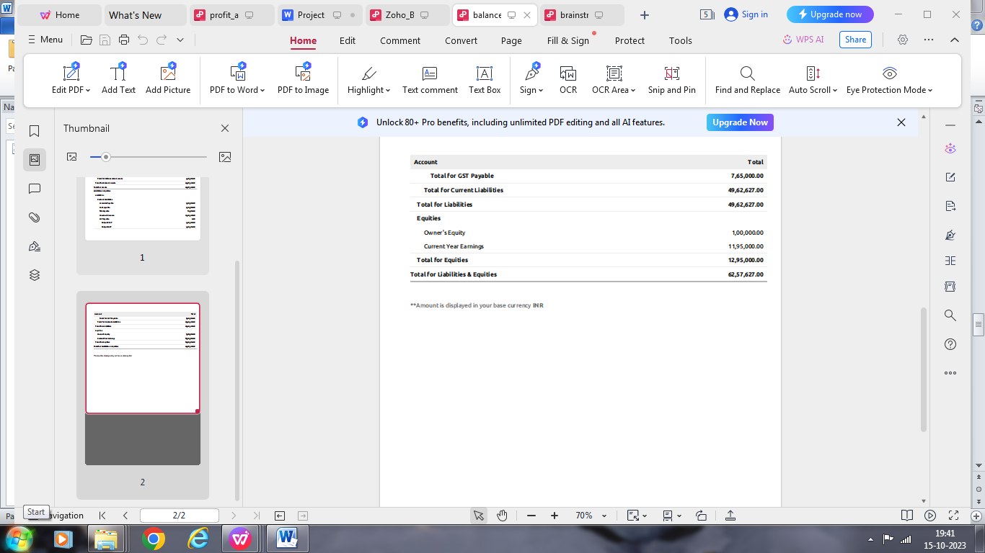

3. GST Reports

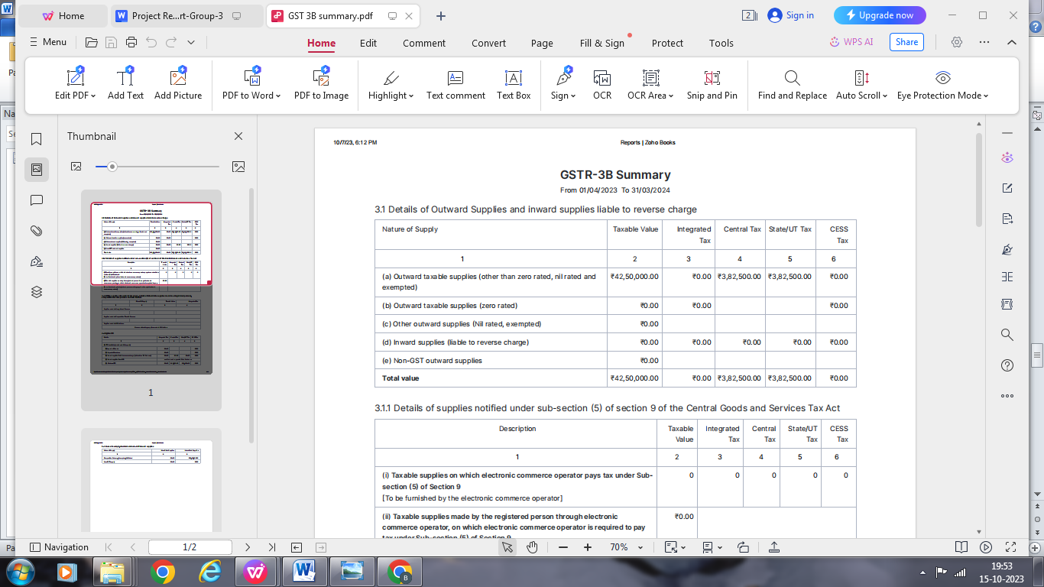

4. Journal Report

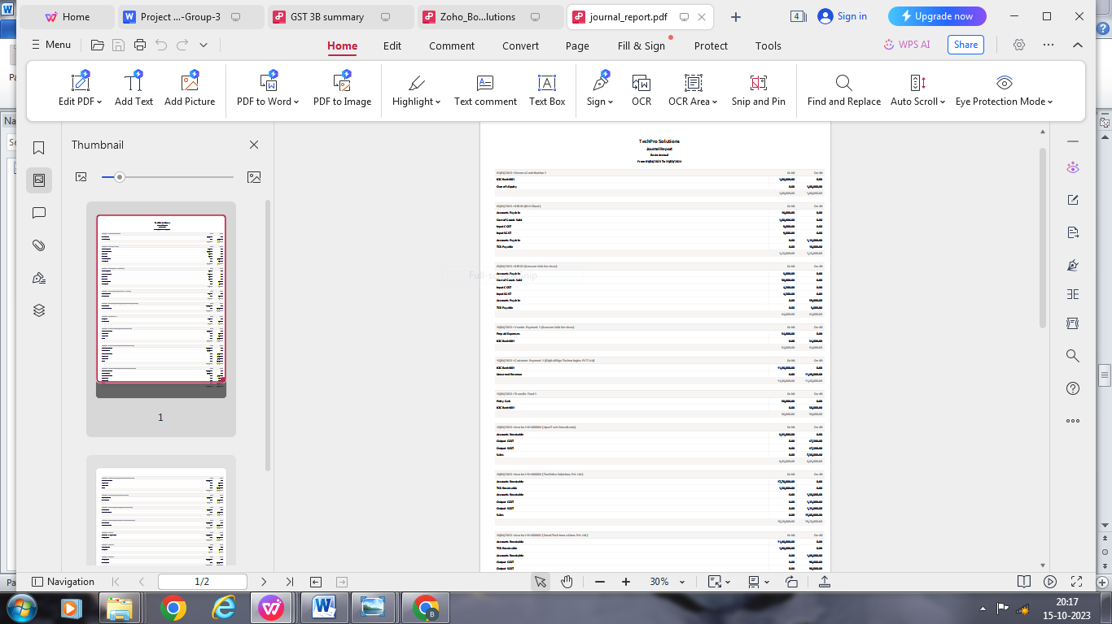

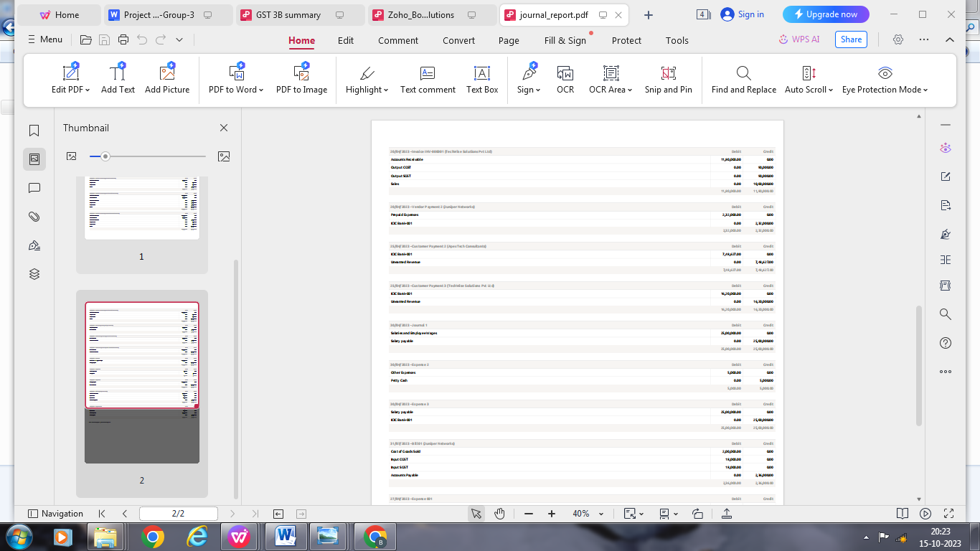

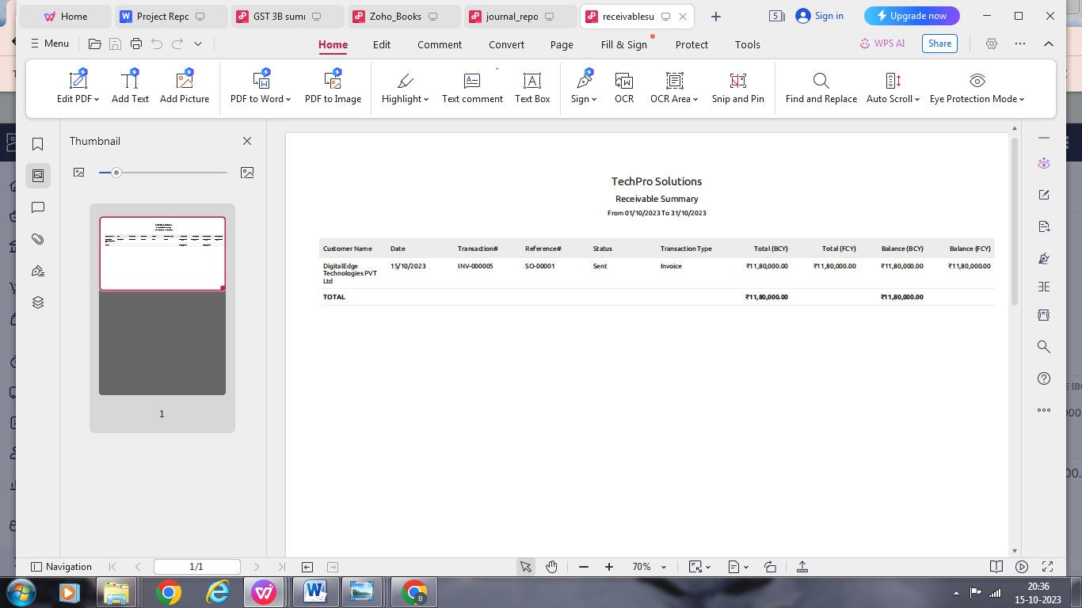5. Accounts Receivable Summary

.

6. Accounts Payable Summary

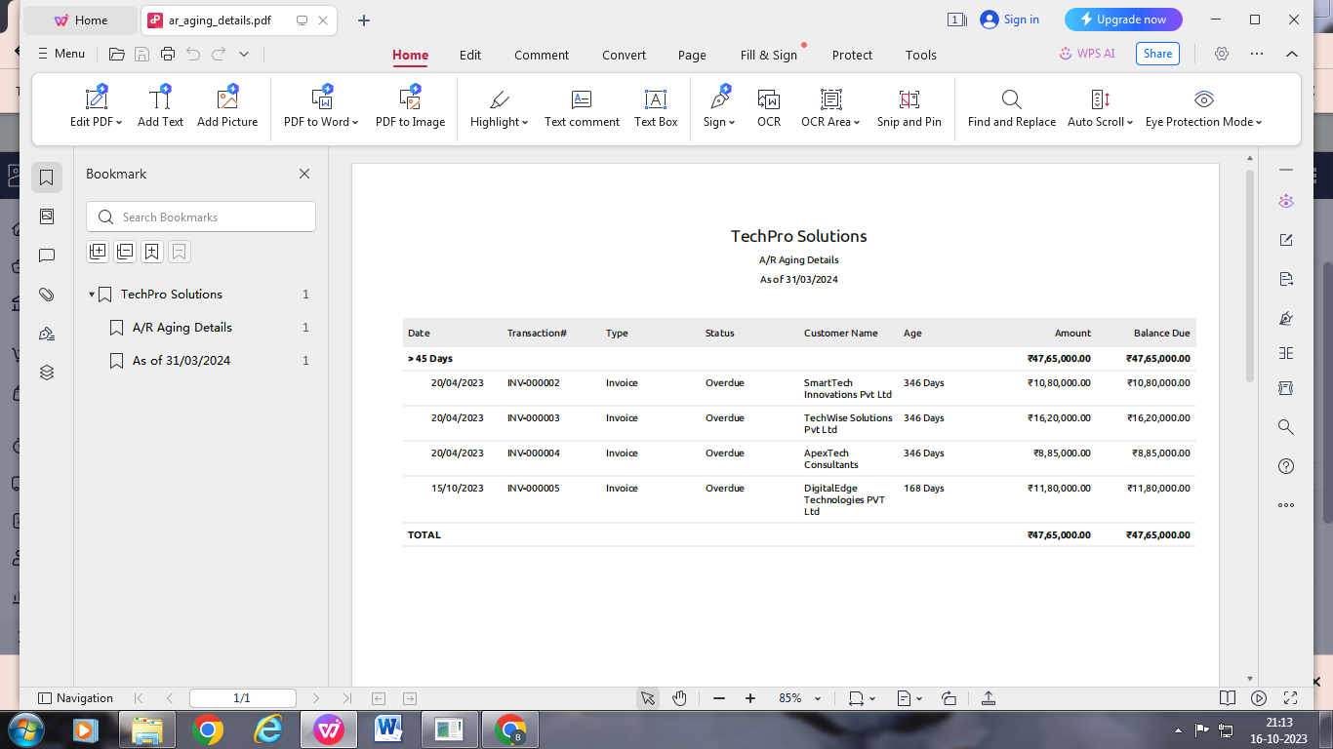

**4. ADVANTAGES & DISADVANTAGES**

List of advantages:

* ZOHO books is cloud based software, so we access the software in any location.
* Creating of Organisation is very easy and user friendly.
* Appearance of software model is very easy to understanding.
* Creation of items, vendors, customers are user friendly while compare with software
* Preparation of purchase order and conversation to purchase Invoice made in a single step.
* Preparation of Sales order and conversation to Sale Invoice made in a single step.
* Default accounting step up is very useful and time saving.
* GST procedure is very easy to enter.

List of disadvantages:

* ZOHO books is cloud based software, which need internet and other technical facility.
* In absence of internet facility, the working in ZOHO books is very difficult.
* There is no secure in data of the organization.

**5. APPLICATIONS**

The ZOHO Books is good software in all type of organization and we get better results instantly. We collect the following data and entered in ZOHO Books in various modules like item creation, Vendor creation, customer creation, preparation of Purchase order, Purchase Invoice, sales order, sale Invoice, Making payment to vendors and Expenses, Received amount from Customers.

**Item creation:**

1. IT Consulting – Selling Price Rs. 10,000/- per Hr
2. . 2. Software Development – Selling Price Rs. 20,000/- per Hr.
3. 3. Web Maintainence – Selling Price Rs. 30,000/- per Hr
4. 4. Cloud Services – Selling Price Rs. 15,000/- per Hr.
5. 5. Cybersecurity – Selling Price Rs. 10,000/- per Hr.

Output GST @ 18% is applicable for all the above services

**Vendors Creation:**

1. Juniper Networks (GST registered)
2. Amazon Web Services (AWS) (GST registered)
3. IBM Cloud (GST registered)
4. Comcast Telecom and Internet (GST registered)
5. Randstad Technologies (Non GST)

**Customers Creation:**

1. TechWise Solutions Pvt Ltd (GST Registered)

2. DigitalEdge Technologies PVT Ltd (GST Registed)

3. SmartTech Innovations Pvt Ltd (GST Registered).

4. ApexTech Consultants (Export) Currency in USD “$”.

**Preparation of Purchase order, Purchase Invoice:**

1. 05-04-2023 Juniper Networks- Networkig Equipment- Qty 200 @ Rs.1000/- each GST @ 18%

**Preparation of sales order, sale Invoice:**

1. 05-04-2023 Cloud Database- Amazon Wed Services- Rs.50,000/- pm GST @ 18%

2. 05-04-2023 Cloud Database- IBM Cloud- Rs.1,00,000/-pm GST @ 18%

**Preparation of sales order, sale Invoice:**

1. 10/04/2023 DigitalEdge Technologies PVT Ltd - 100 Hrs of IT Consultation - paid through bank on 25/04/2023

2. 20-04-2023 SmartTech Innovations Pvt Ltd- 50Hrs for Software Development_TDS@10%

3. 20-04-2023 TechWise Solutions Pvt Ltd – 50Hrs for Web Maintainance_TDC@10%

4. 20-04-2023 ApexTech Consultants- 50Hrs for Cloud Services

**Making payment to vendors and Expenses:**

1. Employee salaries of total Rs.25,00,000/- paid through bank on 30th April 2023.
2. 1. Office Rent Rs.2,00,000/- excluding GST @ 18% Total Invoice Value Rs.2,36,000/- TDS @10%
3. Other miscellaneous expenses Rs.5,000/- paid in cash
4. 10-04-2023 Paid to Amazon Web Services 54000
5. 20-04-2023 Paid to Juniper Networks 232000
6. 30-04-2023 Salary Paid 2500000

**Received amount from Customers:**

1. 25-04-2023 Received from ApexTech Consultants 748627
2. 25-04-2023 Received from Techwise Solutions 162000

**6. CONCLUSION:**

In maintaining of accounts of Tec in Zoho books is Techpro solution very smart in all the aspects of entries. The basic accounting concept is enough for the operating person(Accountant/Data entry operator). This software is applicable for all types of organization. The entry models of software are easily understood and interest to work. Whatever reports we need, it’s already default in the report models. Totally it’s a good and very useful to the entire entrepreneur with low cost for operating financial department.

**7. FUTURE SCOPE:**

The idea for the founders of ZOHO Books is amazing and very clever. This is a great milestone in the field of accounts maintenance. They offer various plane as per the requirement of the proprietors. It’s a good gift to all the entrepreneurs.